Modifications to Coors Bowling and Capcom Bowling JAMMA PCB’s
By John Spina

My goal was two-fold. I wanted to put a TEST switch on the PC board as opposed to a separate switch on the game cabinet. The other goal was to have the ability to switch from the CAPCOM BOWLING programming to the COORS LIGHT programming using the same JAMMA board. I will cover the test switch first.

Many JAMMA boards have this test switch on the board, but the Capcom didn’t so I found a simple way to do it. It was easy enough by simply bridging capacitor C60 on the Capcom PC board with a tactile switch, Digi-Key part number SW263CT-ND or equivalent. The switch installs as shown:
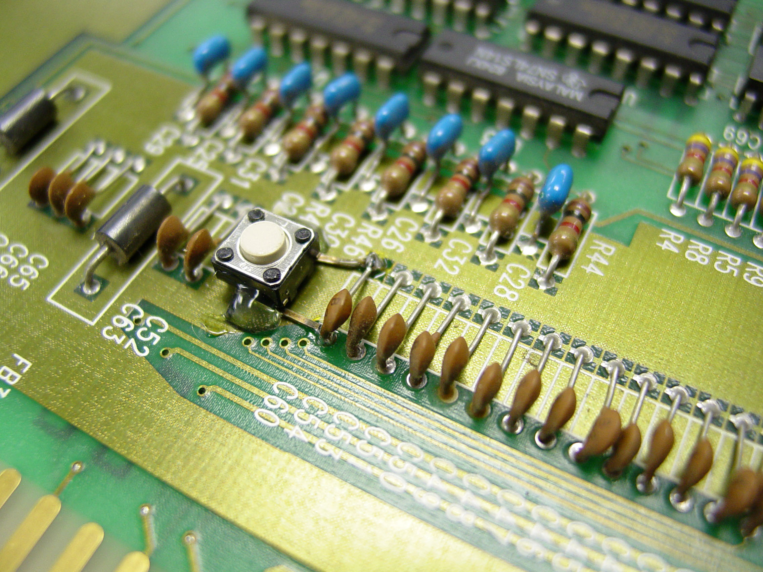
I used hot glue to secure the switch to the PC board, but you can use silicone sealant or equivalent. The two pins of the switch are soldered to the capacitor leads on the top, and the switch is held in place by the solder joints and the hot glue.

The other project involves a few parts:
5ea. 28 pin DIP IC socket
5 ea. 27C512 EPROM, 20us or better
1 ea. Miniature toggle switch, Digi-Key part number 360-1057-ND
24 in. 28ga. Wire-wrap insulated wire
1 ea. 4.7k 1/4watt resistor
EPROM images for the CAPCOM Bowling and COORS LIGHT bowling games:
Graphics 2
Graphics 1
Graphics 0
Program U6
Sounds U30

Each of the original program chips are programmed on a 27C256 EPROM. I placed the COORS data on the first half of the 27C512 data space (0000-7fff hex) and the CAPCOM data on the second half of the chip (8000-ffff hex). Since the program data is stacked, by enabling the highest order address line with either a 0 (neg.) or 1 (5V) you can select which data you wish to use by a simple toggle switch.
First, remove all five of the original EPROM chips. On each DIP socket, bend the No. 1 pin inward and solder a short length of wire onto each. The U30 chip will need about 9 in. of wire on it, and the other four sockets will only need maybe 2 in. of wire on the pin.
Place the sockets into the five locations on the board as shown. Note that the wire soldered to pin No. 1 of each socket will exit from under the socket and will then be all joined together at the edge of the PC board as shown:
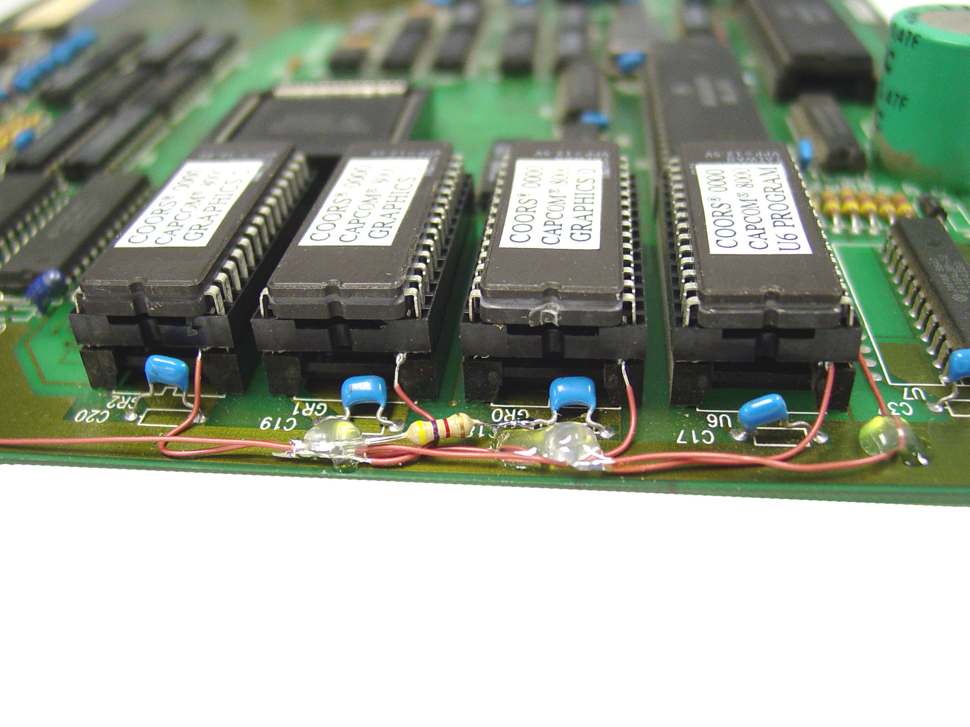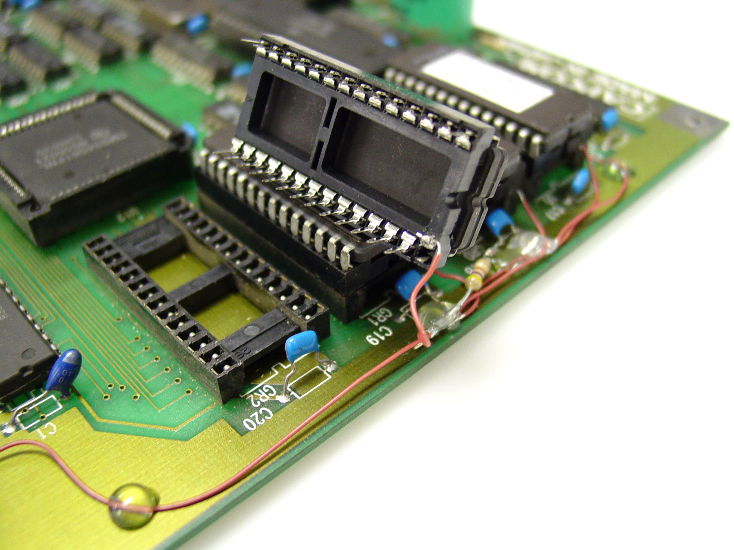
Each wire from each IC location was then soldered to this location and the resistor is added to that solder joint, with one end of the resistor to ground. Using an additional length of wire, I attached it to the small toggle switch common pin, the soldered the outer lead of the switch to a 5 volt source as shown here. Install the newly-programmed EPROMS into its respective location.
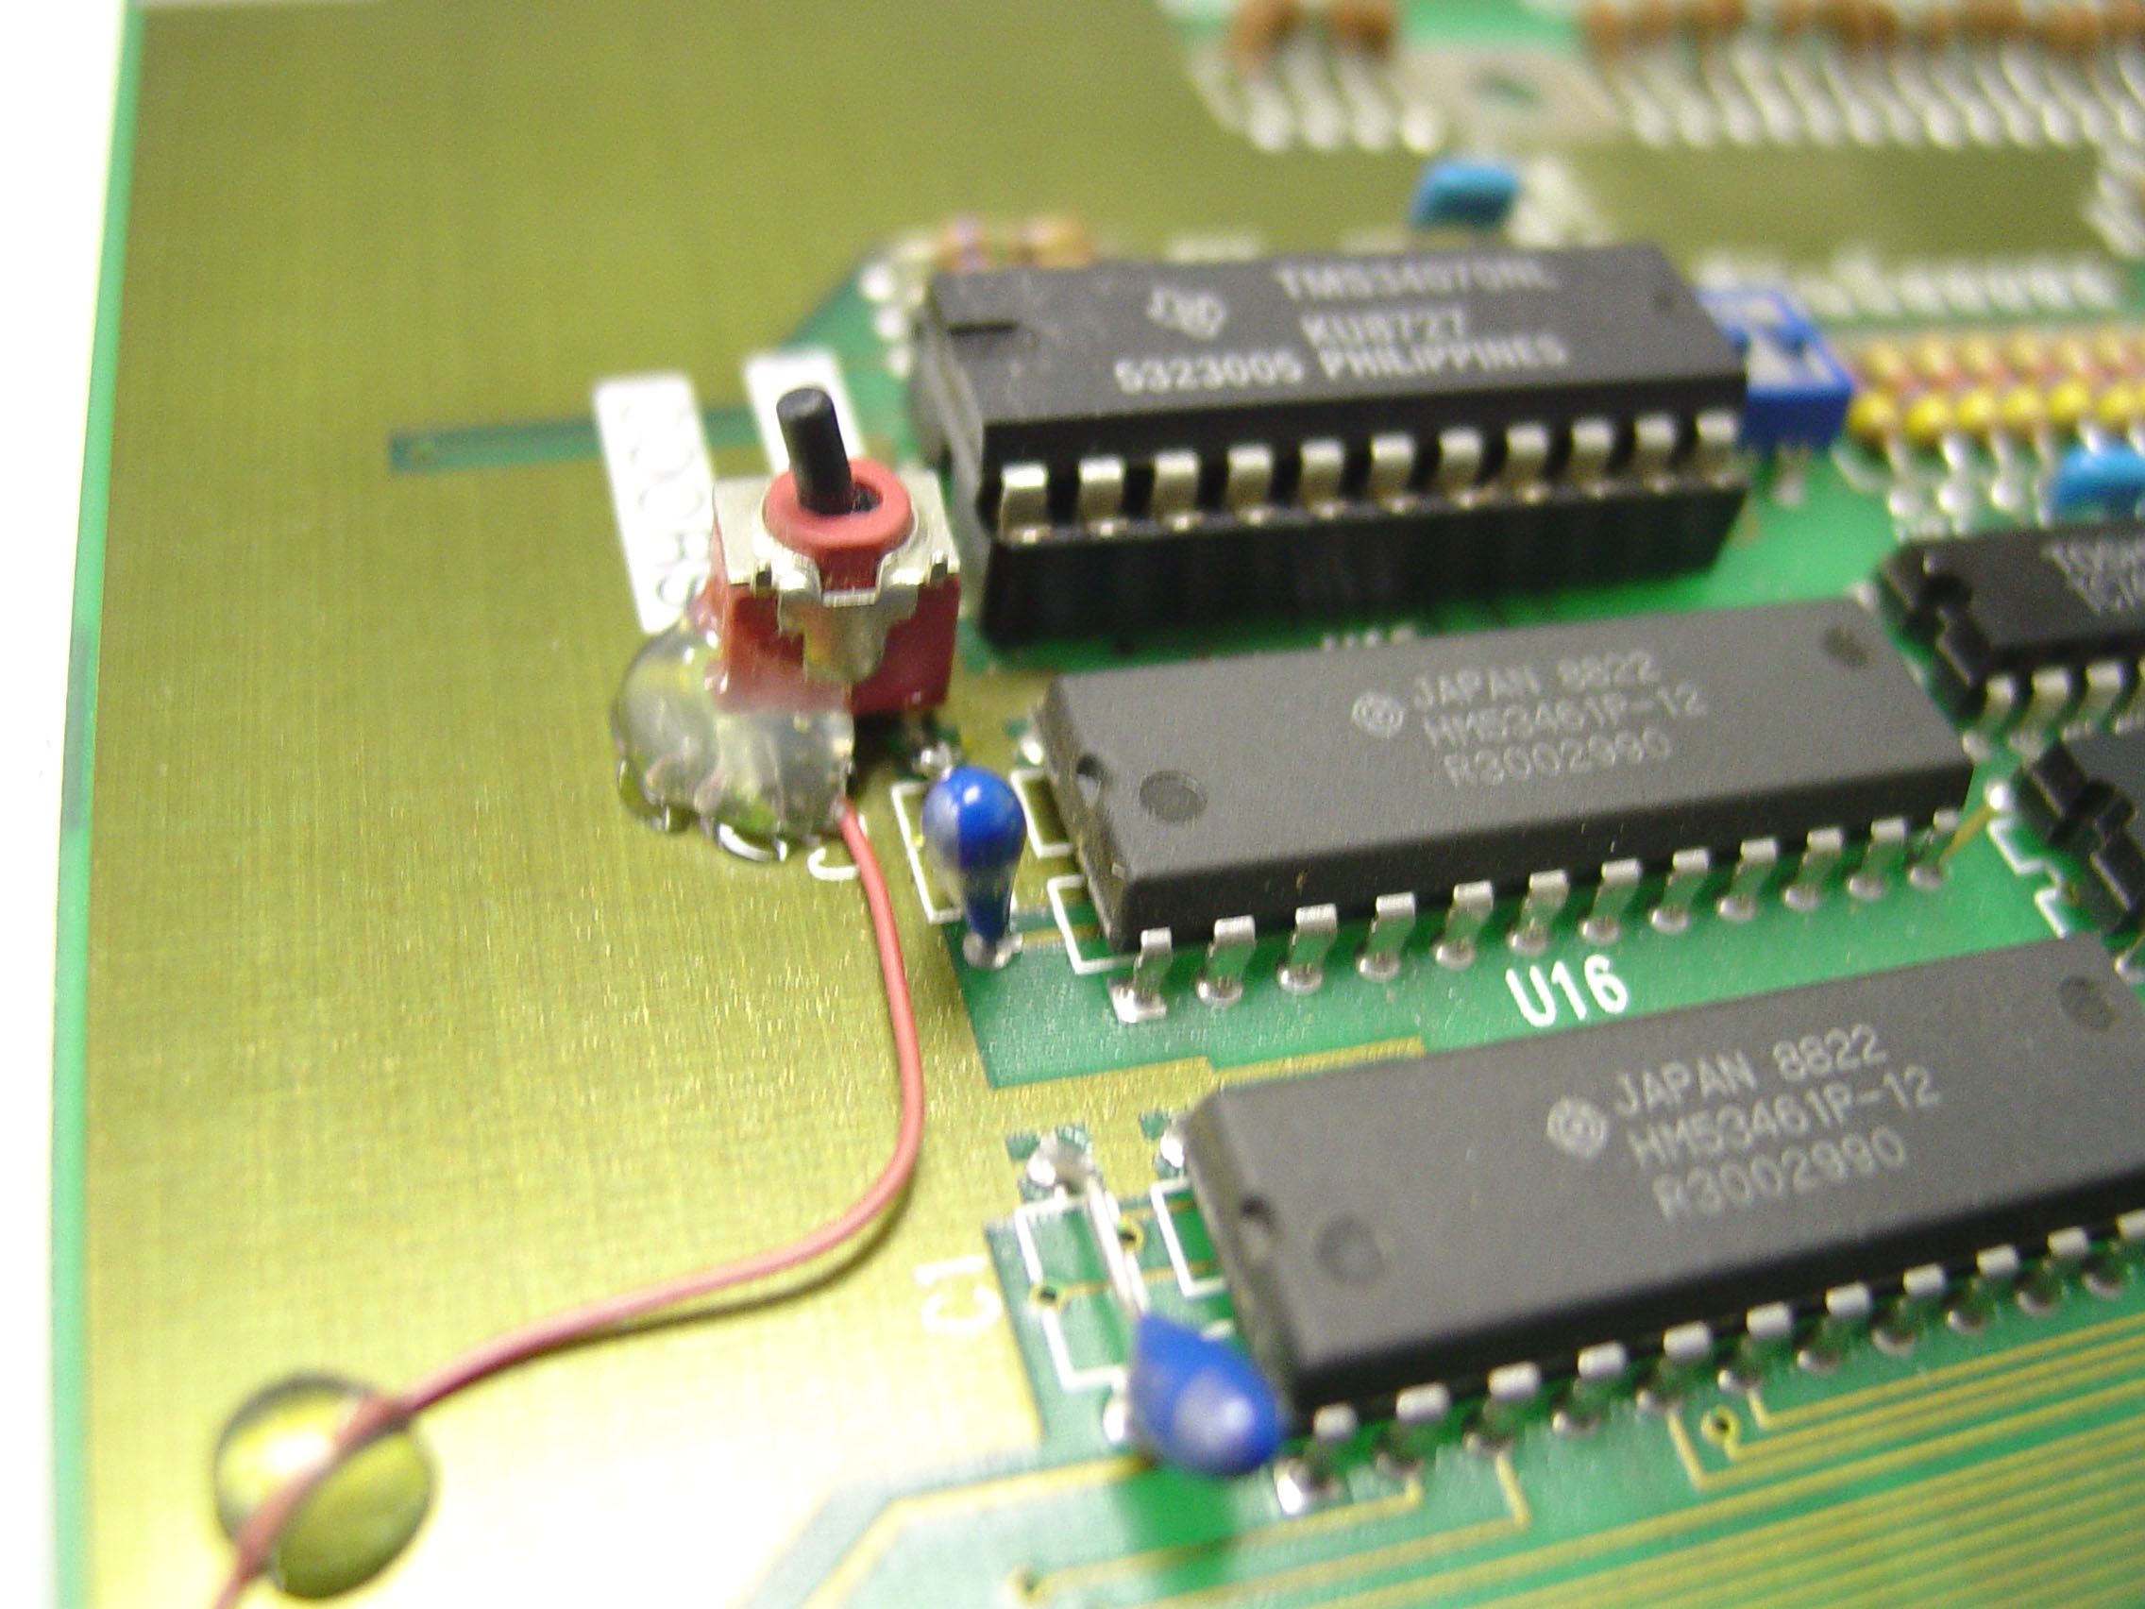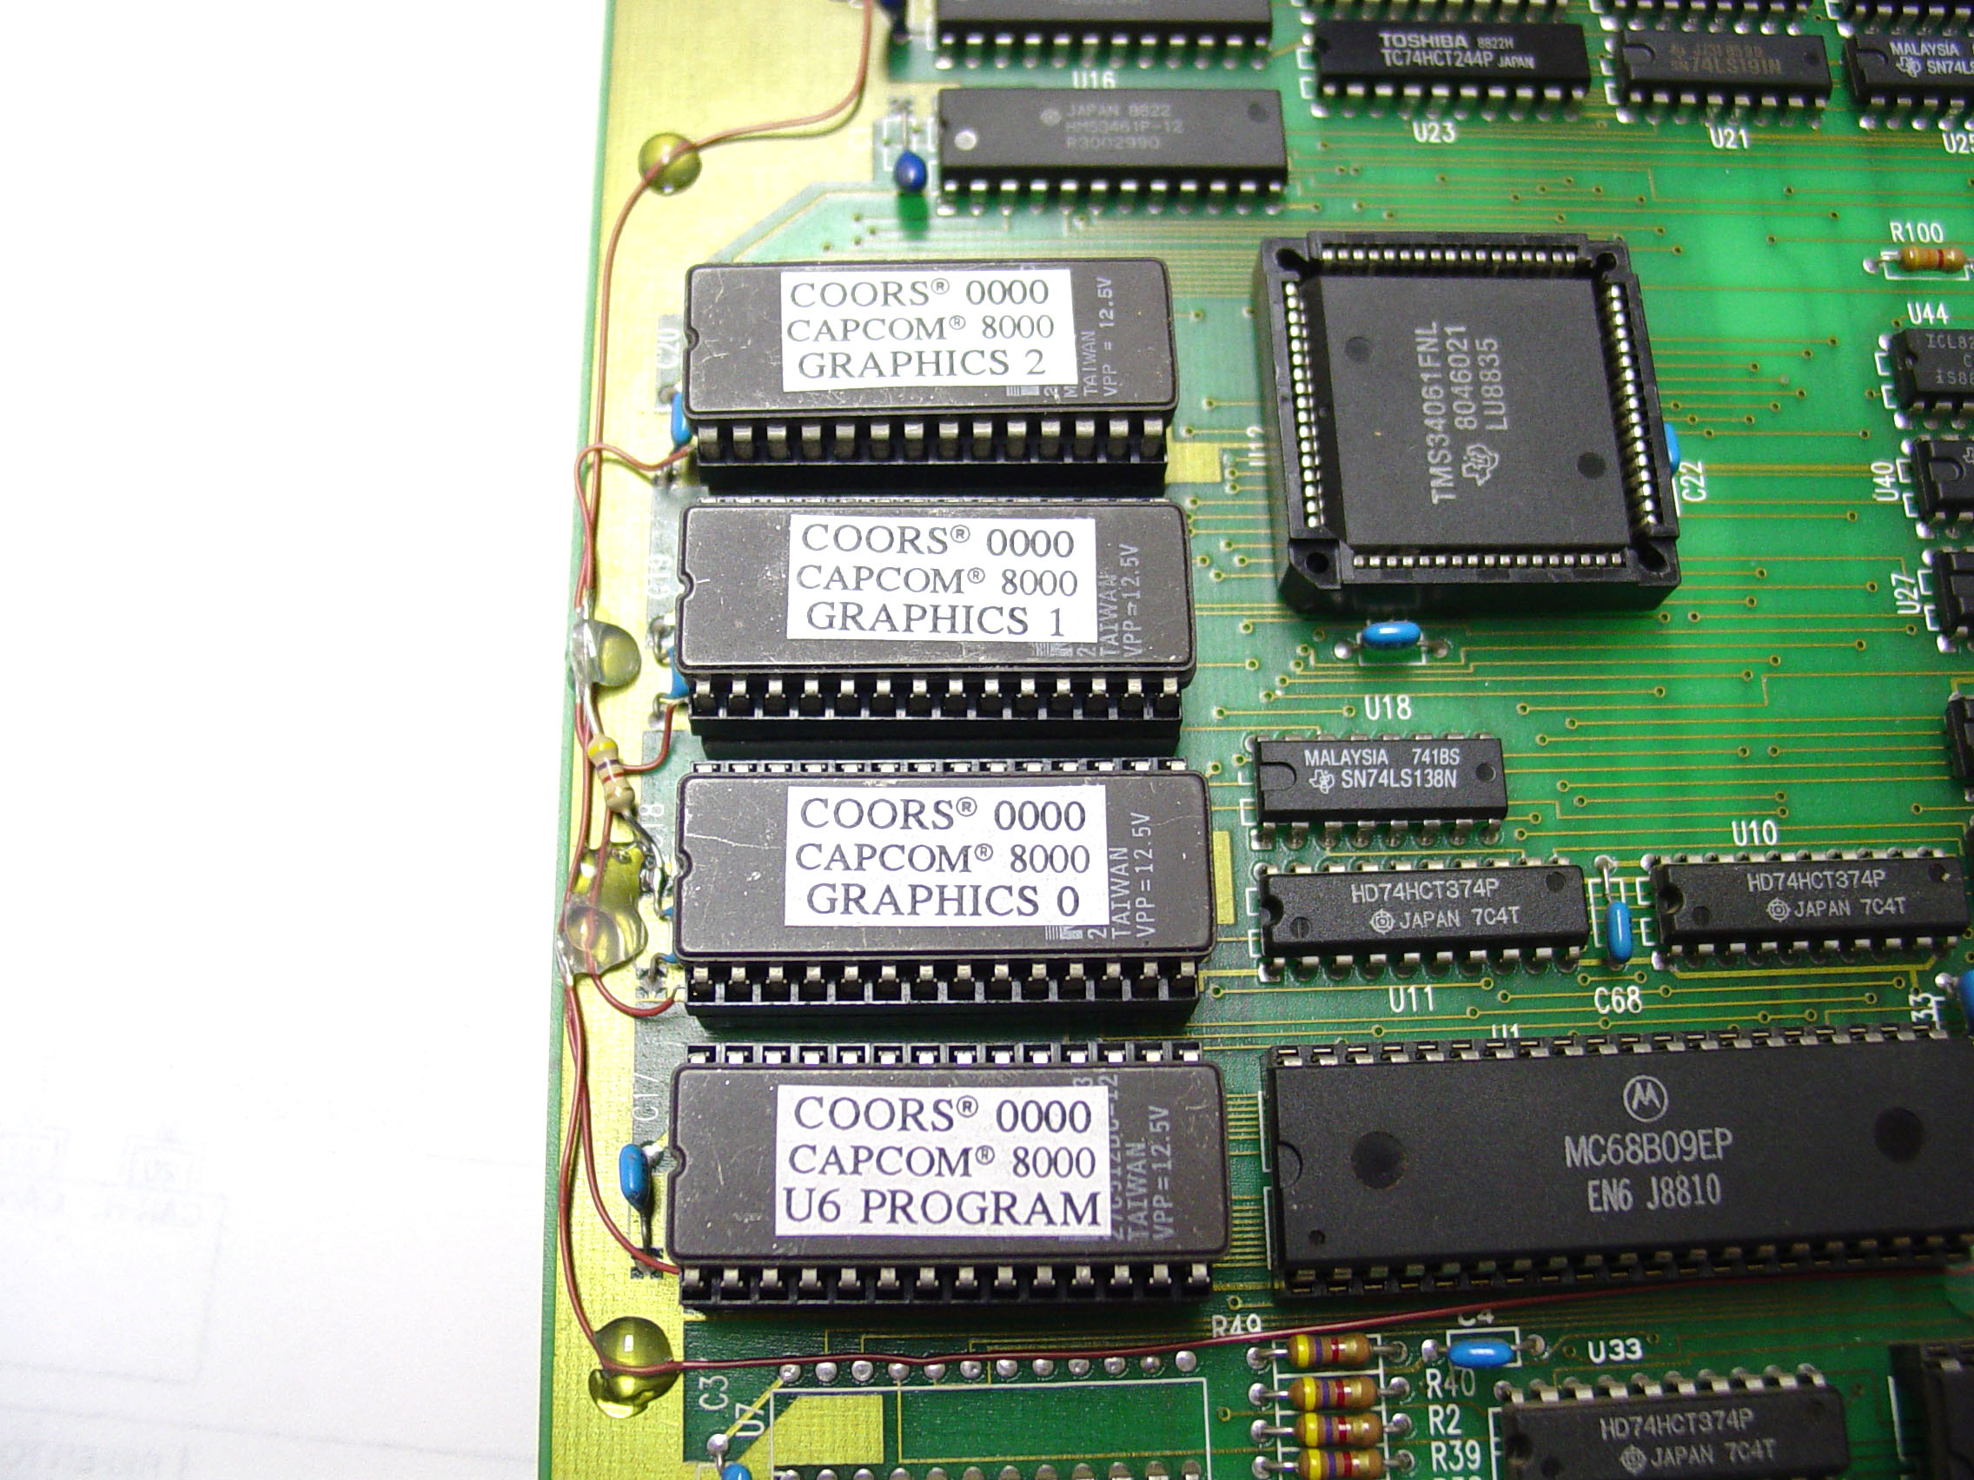
I used the positive side of the tantalum capacitor at U15. 