Optical Gun Rapid Fire Module
Operation of the circuit:

- Allow for normal gun operation for the first ½ second of operation.
- Fire off three triggered shots rapidly, ½ second after maintaining continuous trigger.
- Fire a “blank” to reload the gun.
- Fire off another three triggered shots.
- Repeat this process continuously until the gun trigger is released.

PARTS LISTING
D1 – 1N4148
D2 – 1N4148
C1 – 0.1uF 50V 0.200 lead spacing
C2 – 0.1uF 50V 0.200 lead spacing
C3 – 1.0uF 16V Tantalum
C4 – 0.1uF 50V 0.200 lead spacing
IC1 – MC 14011 BCP quad NAND gate
IC2 – MC 14017 BCP 10 stage Johnson counter
R1 – 10K ¼ watt
R2 – 100K ¼ watt
R3 – 1.2MEG ¼ watt
R4 – 300K ¼ watt
R5 – 820K ¼ watt
R6 – 10K ¼ watt
R7 – 22K ¼ watt
Q1 – 2N4401 NPN transistor
PCB1 – RapidFire PCB
CONN1 – Molex 22-03-2041 Header (input side)
CONN2 – Molex 22-01-2047 Housing (output side)
TERMS – Molex 08-50-0114 crimp terminal (4 required)
MISC – 22 gage insulated wire, 4 ea. 6 in. long
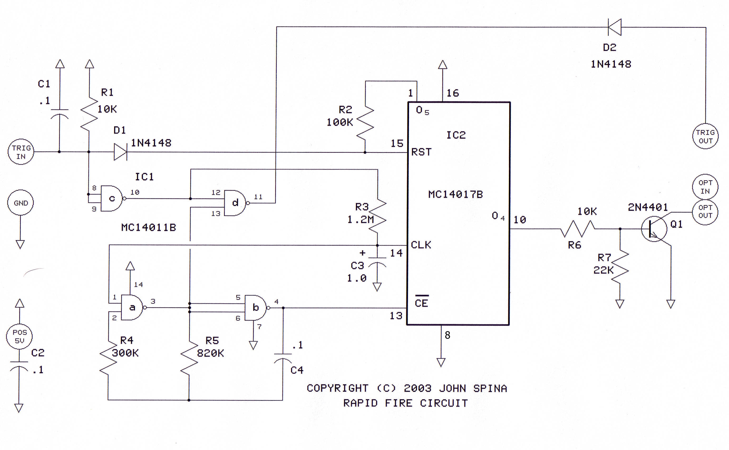
NOTE: This circuit is designed to operate with a standard “HAPP” optical gun. It has not been tested on other optical guns. Operation of this circuit may vary with different JAMMA controls.

Theory of Operation

The TRIG IN is the gun trigger input. R1 and C1 form a “debounce” for the switch contacts. IC1c gate inverts the signal to pin 12 of IC1d which further inverts the signal back to a negative-going pulse, fed through D2, to the trigger output. This assures that the negative trigger input produces an immediate negative trigger output, so every time the trigger on the gun is pulled, the output sends a negative pulse. Pin 13 of IC1d is high when pin 1 of IC1a (thru resistor R3) is low (via pin 10 of IC1c). When Trigger is pulled, IC1c pin 10 goes high and pulls IC1a high after the timeout of R3/C3 (approximately ½ second). This starts the oscillator comprised of IC1a, IC1b, R4, R5 and C4. The oscillator causes pin 13 of IC1d to swing low and high at a rate of 4 pulses per second, causing the output pin 11 of IC1d to toggle. This state continues as long as the trigger input is grounded. The oscillator circuit feeds Johnson counter IC2 input pin 13 and causes the counter to increment one count for each pulse. At the fourth pulse, output O4 (pin 10) goes high, biasing the base of transistor Q1 thru resistor R6 (resistor R7 negatively biases Q1 to keep it turned off during counter reset) to provide a blanking output to the OPT OUT pin, effectively grounding the optical signal out during the duration of that pulse. The Johnson counter then increments to O5, causing a reset signal thru resistor R2, resetting the counting sequence and cycling the counter again. This repeats itself over and over until the trigger is released. Diode D1 forward biases to provide a reset condition to IC2 when the trigger is not pulled, keeping the circuit in “standby” mode.

Once the PC board is completed, you can affix it to the cabinet side near the gun connectors. Bs sure to keep the PC board away from objects that could potentially short-circuit the conductors on the board. It would be a good idea to place the PC board in a plastic enclosure.
To operate the circuit, you simply fire the gun and reload as you would normally, If you desire the rapid-fire feature, you simply squeeze and hold the trigger. After about a half second, the rapid-fire sequence begins. Three valid shots are fired off, then the gun fires a blank, which reloads the chamber. The process repeats itself over and over again until you release the trigger. This puts the gun back to normal optical mode. Be sure you plug the circuit in-between the optical gun connection properly…always match the colors to the PC board as shown:
Copyright ©2003 Caspers Electronics Inc. All rights reserved.
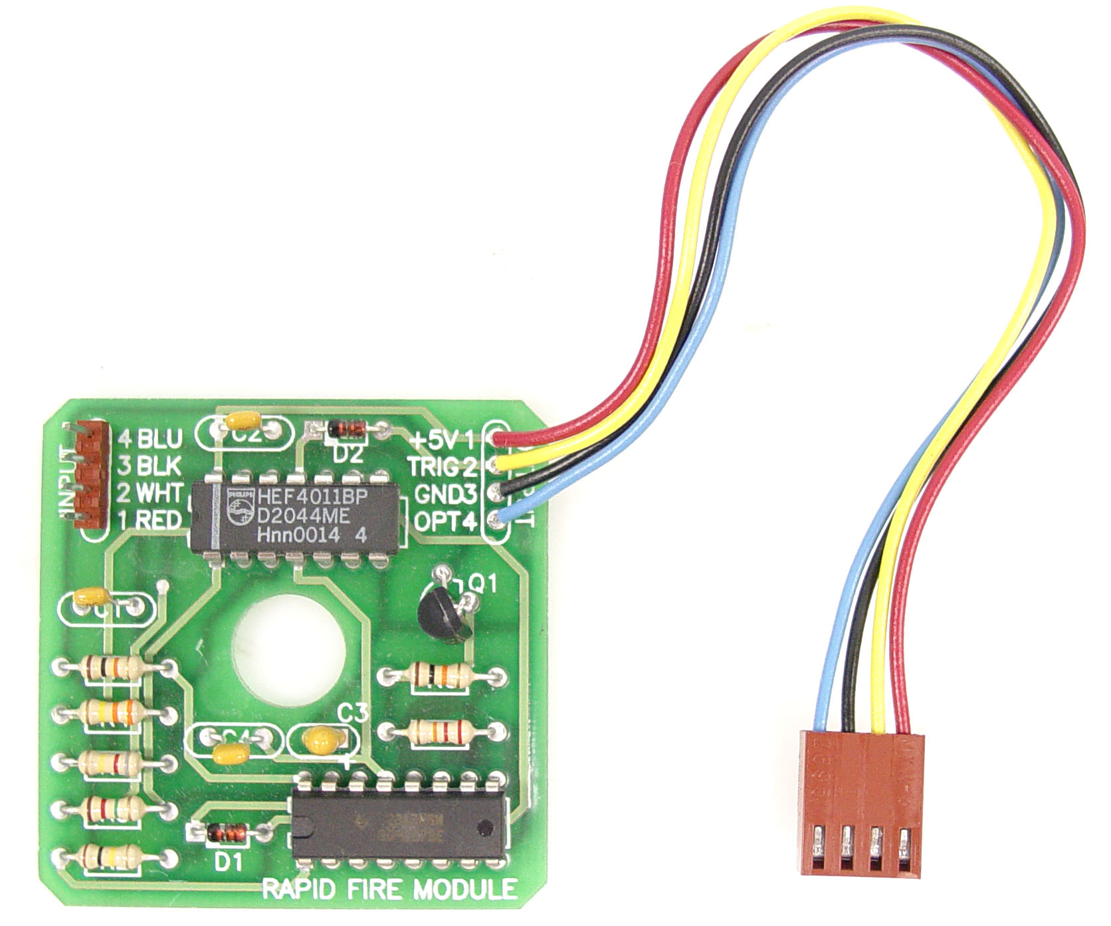
Plug HAPP gun into this connector
Plug this end into JAMMA gun input on game board PCB

