Optical Gun Rapid Fire Module

I’ve always been obsessed with driving games such as Out Run and Cruisin USA, and found them challenging and fun. At the same time, I had the same fun playing the shooter games and found them to be equally challenging. My basement arcade had pinball games and driving games, but no shooting games, so I went internet surfing to add to the game room.

I started out by purchasing a Lethal Enforcers Jamma PC board, figuring I could use it in any Jamma cabinet that has a horizontal monitor. Soon thereafter, I found a dedicated Lethal Enforcers II arcade game with the idea of putting both games in the same cabinet. The Lethal Enforcers II game I purchased uses a mirror and inverts the image so you have more depth in the field of play, but the original Lethal was a direct shooter with no mirror. After a setup change, I was able to use either game in the cabinet, and both would be properly oriented.

The game I purchased was equipped with cast aluminum optical pistols, fairly heavy and somewhat awkward to use. Once I started playing the game regularly, I found that the constant shooting and reloading took a considerable toll on my wrists and forearms, and it would literally wear you out after only one game. I imagine this fatigue plays into Carpal Tunnel Syndrome in a big way (funny, I don’t remember being so tired playing the game when it first hit the arcades). Anyway, I’m generally lazy and set out to find a way to make it easier to play, less gun movement, easier on the wrists, and so on.

My first instinct was to replace the cast aluminum pistols with the lighter, plastic pistols commonly used. So I found a set of plastic guns, blue and pink, and installed them into the game. Guess what? Still beats you up after only one game! With that disappointing discovery, I set out to find a better way. After a bit of research, I found that the optical gun worked by sending a sync’ed signal back to the processor at a given horizontal line position on the screen only when the trigger is pulled. In fact, every time the trigger is pulled, the rest of the screen flashes white and only the target area is visible to the optics, apparently making it easier to “see” the target. To reload, you move the gun off of the screen, then squeeze the trigger. This sends the trigger pulse to the processor without a horizontal signal, causing the reload. Usually, the game gives you six shots before you need to reload. So, I decided to design an electronic circuit to make life easier.

My goal was simple enough; build a circuit that would shoot three or four shots quickly, then blank the optics to force a reload. But, I also wanted this circuit to allow normal operation to be able to use the pistols the way the game was originally designed. The optical guns used in Konami and many other arcade games generally have four wires which go to the optical gun inputs of the processor board. The four terminals of the connectors have a red wire for +5 volts, a black wire for a ground, a trigger signal and an optical signal. The trigger signal is switched to ground, and the optical signal is amplified internally inside the gun and a pulse train equal to the horizontal frequency is fed to the processor. When reloading the gun, the optical signal must be grounded at the same time the trigger is pulled.

The circuit I designed has a four terminal input and four terminal output. This allows “plug-and-play’ design to make installation real simple. I needed to make the circuit work this way:
- Allow for normal gun operation for the first ½ second of operation.
- Fire off three triggered shots rapidly.
- Fire a “blank” to reload the gun.
- Fire off another three triggered shots.
Bill Of Materials:

D1 – 1N4148
C1 – 0.1uF 50V 0.200 lead spacing
C2 – 0.1uF 50V 0.200 lead spacing
C3 – 1.0uF 16V Tantalum
C4 – 0.1uF 50V 0.200 lead spacing
IC1 – MC 14011 BCP quad NAND gate
IC2 – MC 14017 BCP 10 stage Johnson counter
R1 – 10K ¼ watt
R2 – 100K ¼ watt
R3 – 1.2MEG ¼ watt
R4 – 300K ¼ watt
R5 – 820K ¼ watt
R6 – 10K ¼ watt
R7 – 22K ¼ watt
R8 – 10K ¼ watt
R9 – 10K ¼ watt
R10 – 10K ¼ watt
Q1 – 2N4401 NPN transistor
Q2 – 2N4401 NPN transistor
Q3 – 2N4403 PNP transistor
PCB1 – RapidFire PCB
CONN1 – Molex 22-03-2041 Header (input side)
CONN2 – Molex 22-01-2047 Housing (output side)
TERMS – Molex 08-50-0114 crimp terminal (4 required)
MISC – 22 gage insulated wire, 4 ea. 6 in. long
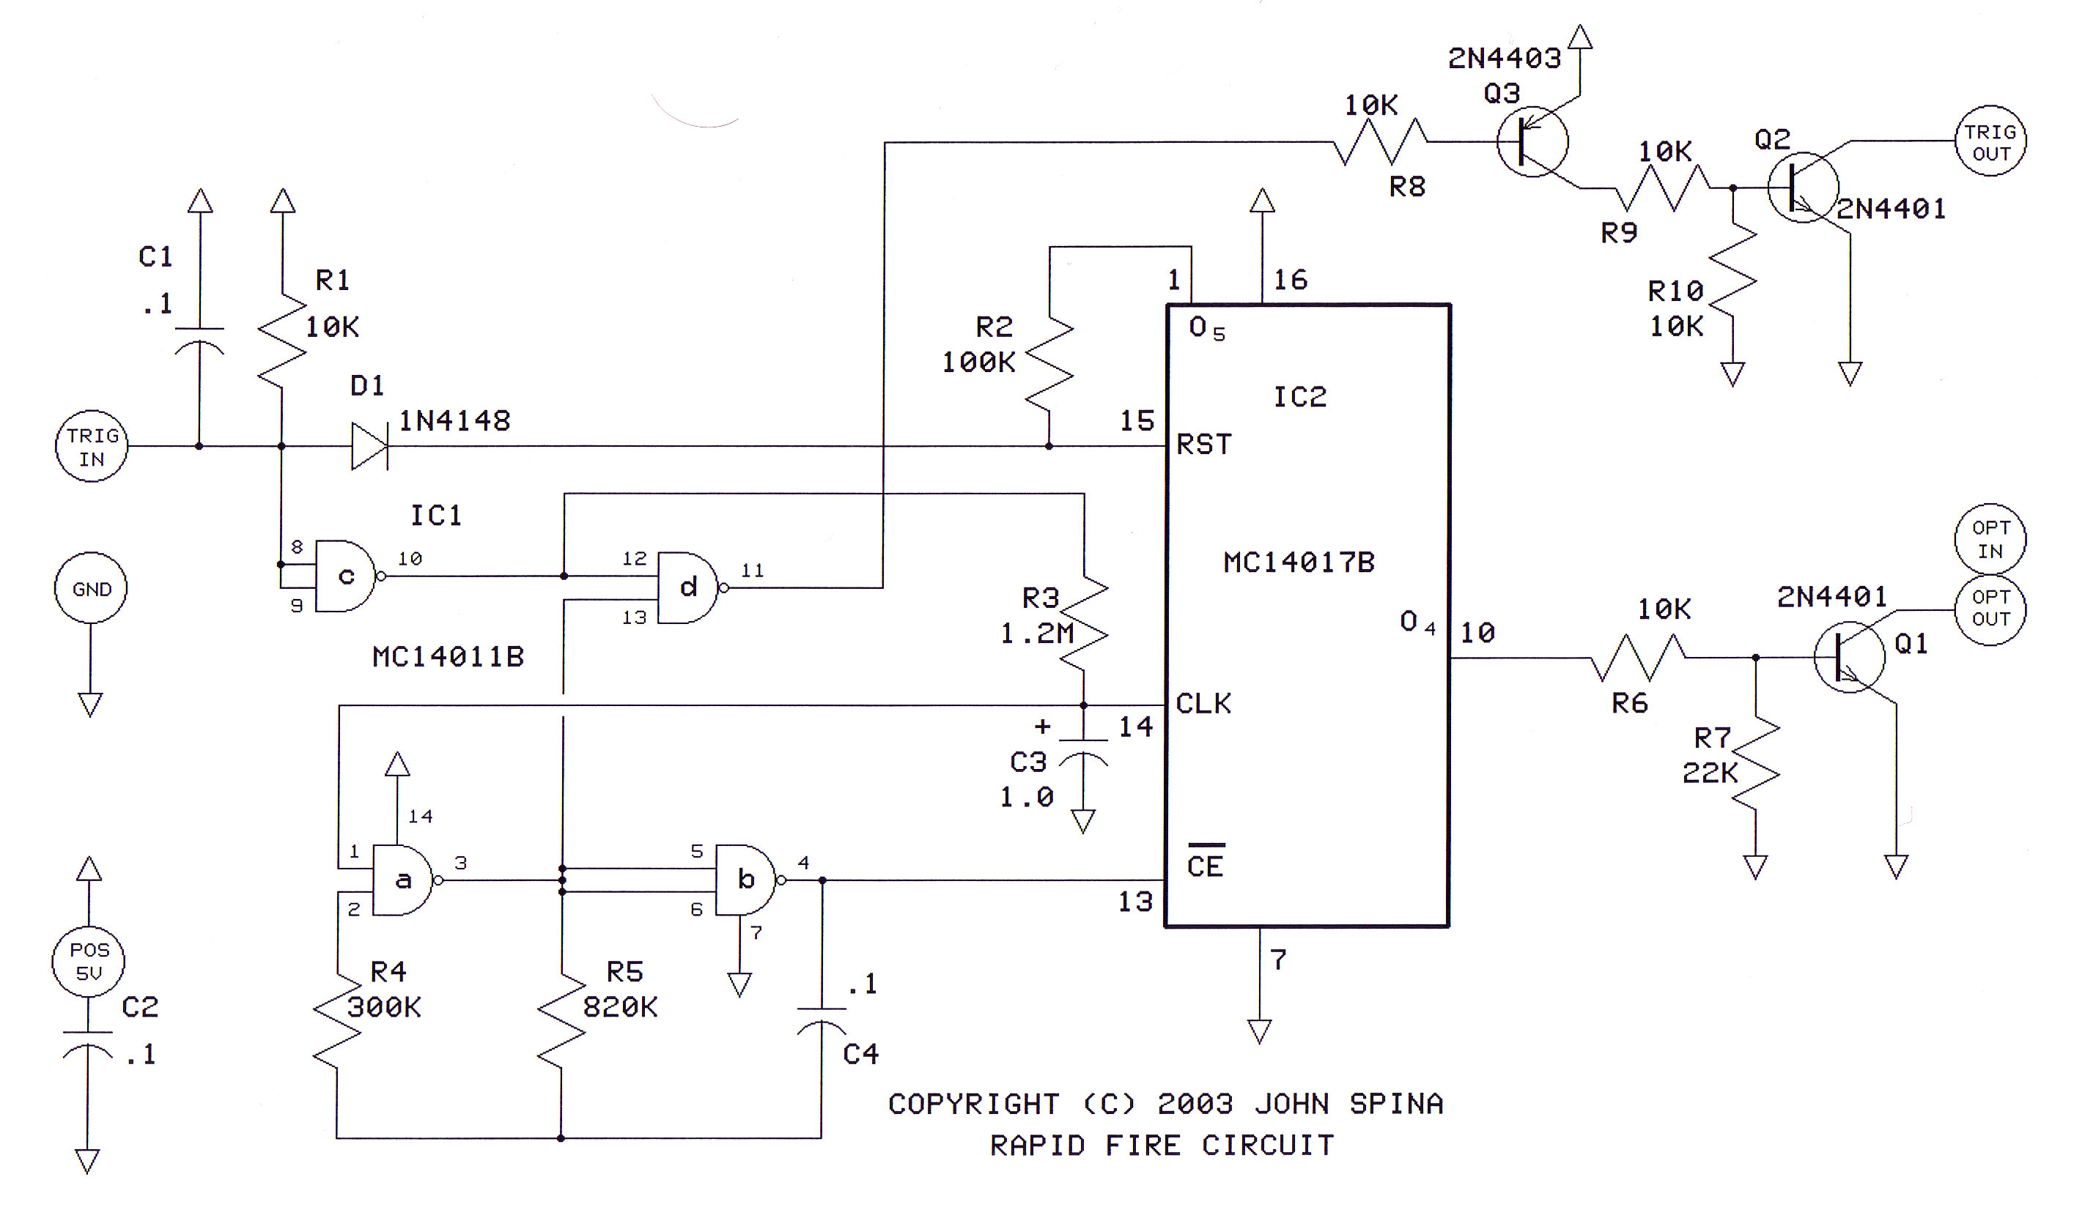
The TRIG IN is the gun trigger input. R1 and C1 form a “debounce” for the switch contacts. IC1c gate inverts the signal to pin 12 of IC1d which further inverts the signal back to a negative-going pulse, fed through R8 to the switch circuit consisting of Q3, R9, R10, and Q2, to the trigger output. This assures that the negative trigger input produces an immediate negative trigger output, so every time the trigger on the gun is pulled, the output sends a negative pulse. Pin 13 of IC1d is high when pin 1 of IC1a (thru resistor R3) is low (via pin 10 of IC1c). When Trigger is pulled, IC1c pin 10 goes high and pulls IC1a high after the timeout of R3/C3 (approximately ½ second). This starts the oscillator comprised of IC1a, IC1b, R4, R5 and C4. The oscillator causes pin 13 of IC1d to swing low and high at a rate of 4 pulses per second, causing the output pin 11 of IC1d to toggle. This state continues as long as the trigger input is grounded. The oscillator circuit feeds Johnson counter IC2 input pin 13 and causes the counter to increment one count for each pulse. At the fourth pulse, output O4 (pin 10) goes high, biasing the base of transistor Q1 thru resistor R6 (resistor R7 negatively biases Q1 to keep it turned off during counter reset) to provide a blanking output to the OPT OUT pin, effectively grounding the optical signal out during the duration of that pulse. The Johnson counter then increments to O5, causing a reset signal thru resistor R2, resetting the counting sequence and cycling the counter again. This repeats itself over and over until the trigger is released. Diode D1 forward biases to provide a reset condition to IC2 when the trigger is not pulled, keeping the circuit in “standby” mode.

To operate the circuit, you simply fire the gun and reload as you would normally, If you desire the rapid-fire feature, you simply squeeze and hold the trigger. After about a half second, the rapid-fire sequence begins. Three valid shots are fired off, then the gun fires a blank, which reloads the chamber. The process repeats itself over and over again until you release the trigger. This puts the gun back to normal optical mode.
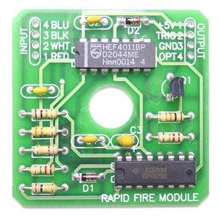
I built my original design on a wire-wrap perf board and the finished design on a 2x2 printed PC board, double sided, plated-thru holes.

You can build your own circuit using the schematic provided, or purchase a complete kit of parts including the PC board, for $16 plus shipping from Casper’s Electronics Inc. 1333 Wilhelm Rd., Mundelein, IL 60060, phone 847 247-0484. John Spina

