Summit Systems Sound Board Modification

The Summit slots fitted with the music feature play two sounds; one when the coin is inserted, and the other that plays as winning coins pass through the hopper exit.

There is, however, a third sound that doesn’t play. This sound is associated with spinning reels, but the machine doesn’t connect to this sound. Apparently the Options Board, which is normally not found in the home-use machines, controlled this unused programmed sound.

You can make your Summit slot machine produce a sound during reel spin. It involves fabrication of a single-chip circuit, a few components, and a means to put it all together. The object is to retrieve the signal from the 3rd Reel Reader sensor “A” and use it to energize the Reel Sounds relay (K2). We chose the 3rd reel because it’s the first to start, and last to stop during game play. But, because the Reel Reader signal “pulses” during reel spin, this will cause the relay to pulse on and off rapidly. So we must add a circuit to condition the relay output, and provide a steady signal to the CPU during reel spin. We will accomplish this by stretching those pulses so they overlap slightly, creating an uninterrupted signal.

The relay output is wired to the opto-isolator that’s dedicated to the Reel Spin sound. The opto-isolator transistor output is then wired to the CPU Reel Sound input. This is the point in which we will stretch the signal to prevent a choppy, pulsed flow of music.

You can test this sound easily. The Sound Board is behind the upper glass. Open the front door, slide the glass out, and remove the fluorescent lamp panel. You will see the sound board mounted to the back wall.
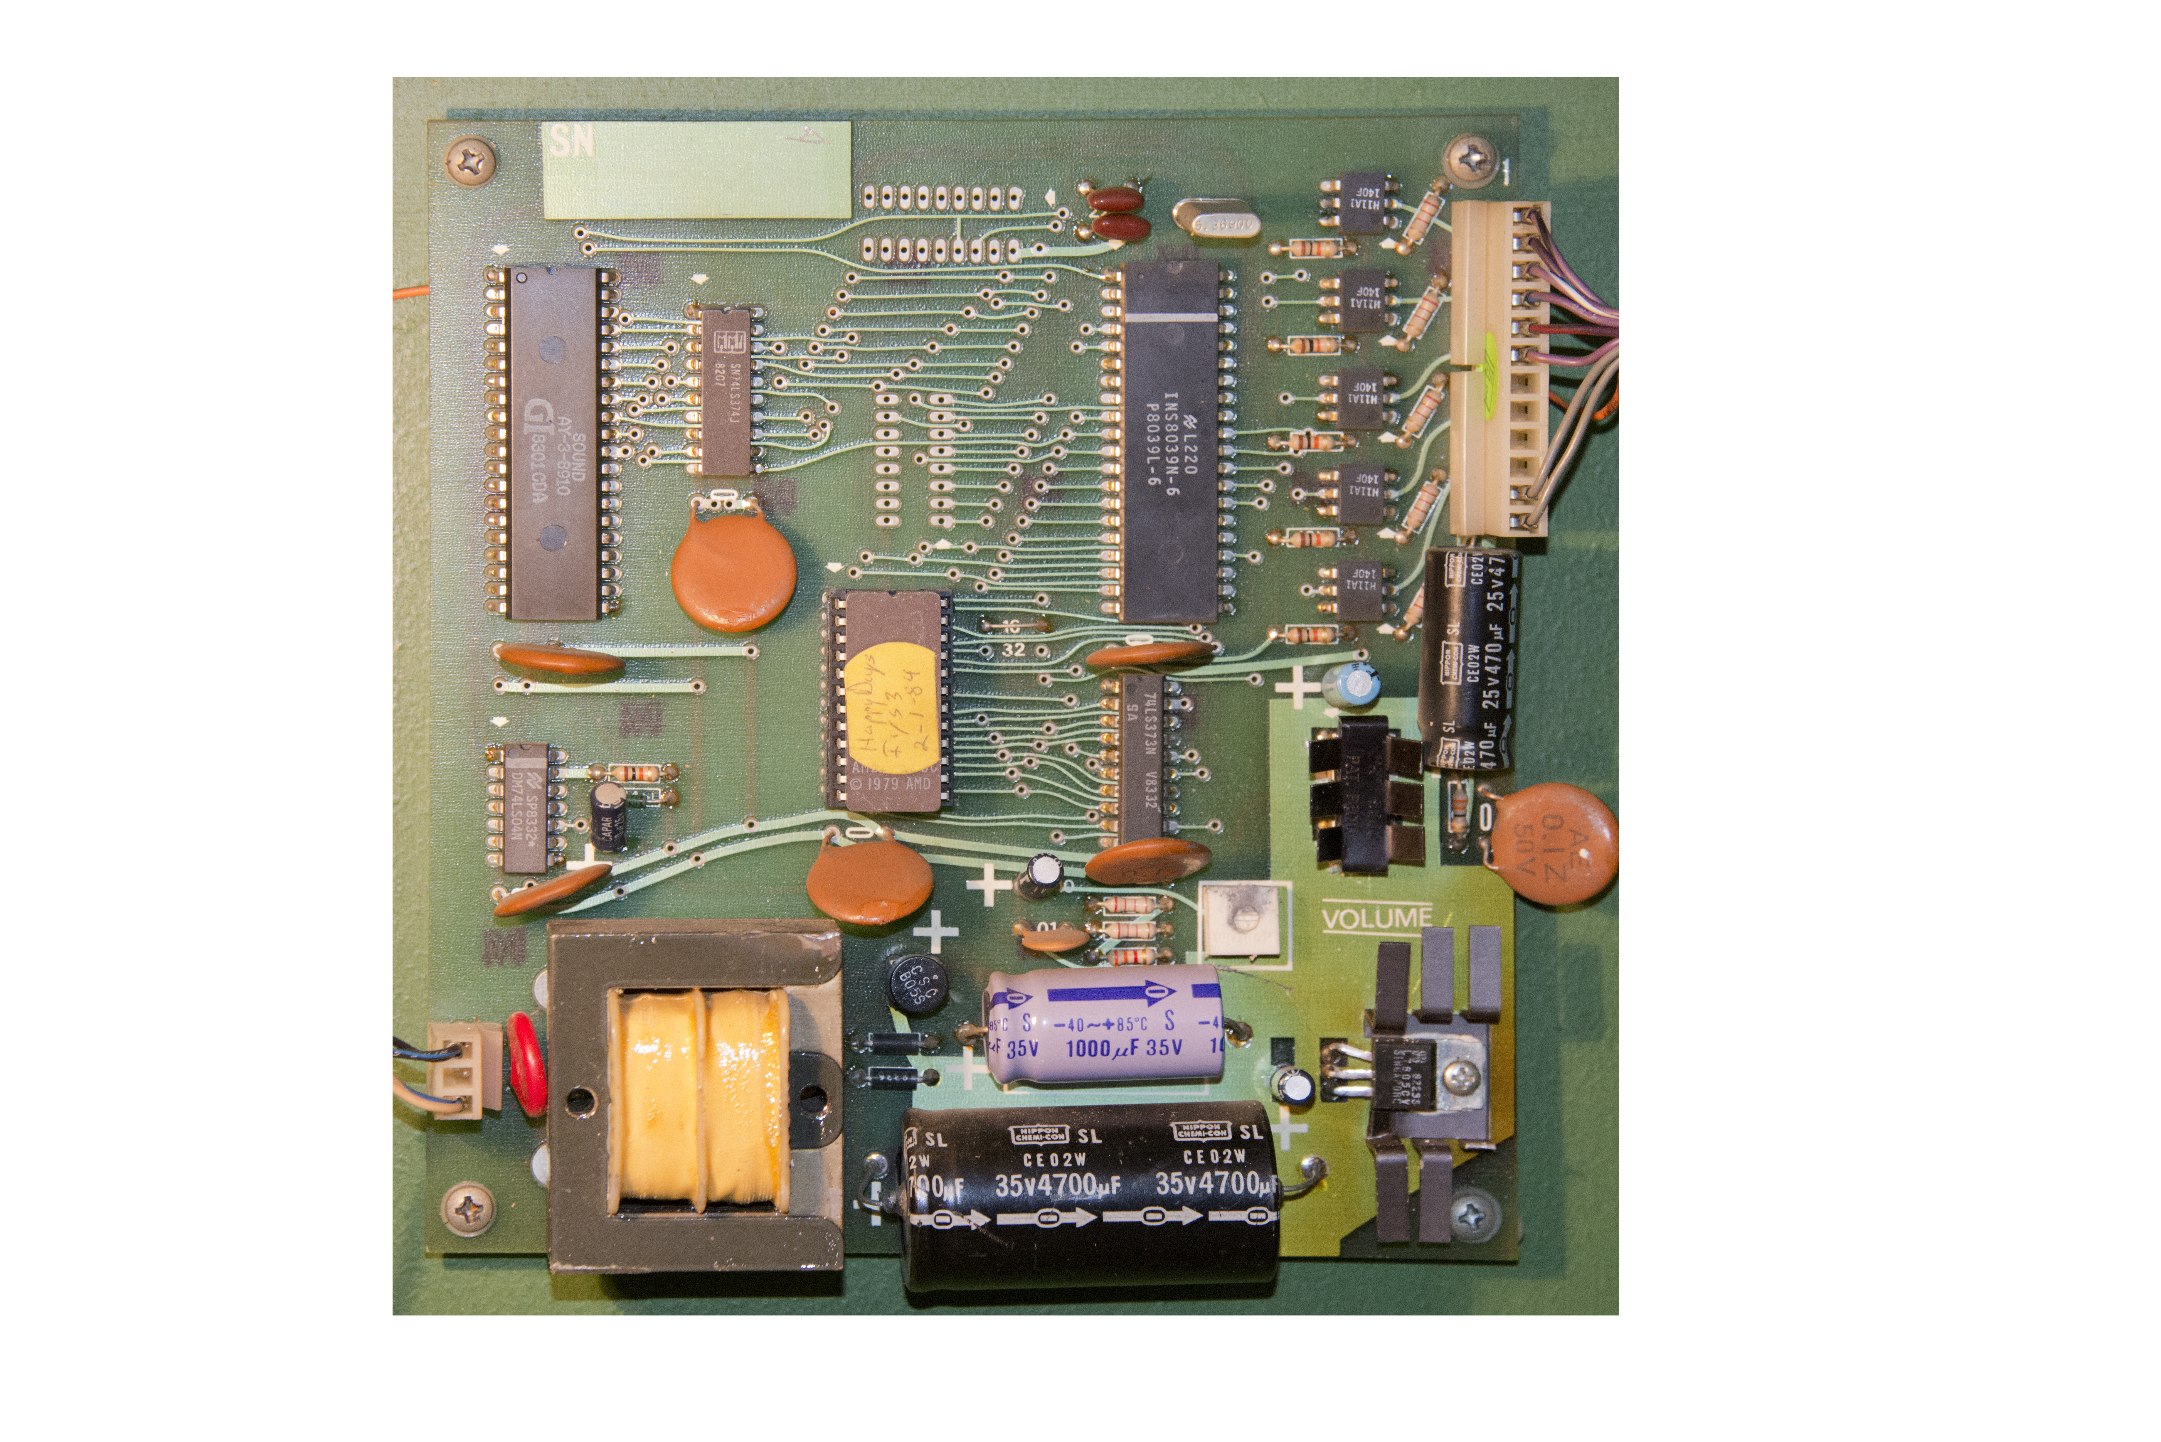
The Sound Board has two connectors; lower left is the AC power, upper right is the connection to the Relay Board and the speaker, behind and to the right of the reels. To test the sounds: Power up the machine. You will then jump the terminals on the large connector. Using a pair of needle nose pliers, jump the two top pins; you will hear the “Win” sound “Happy Days”. Now jump the next two pins down; that’s the “Coin In” sound. Finally, jumping the next two pins will play the “Reel Spin” sound. That’s the sound that will play when the reels spin.
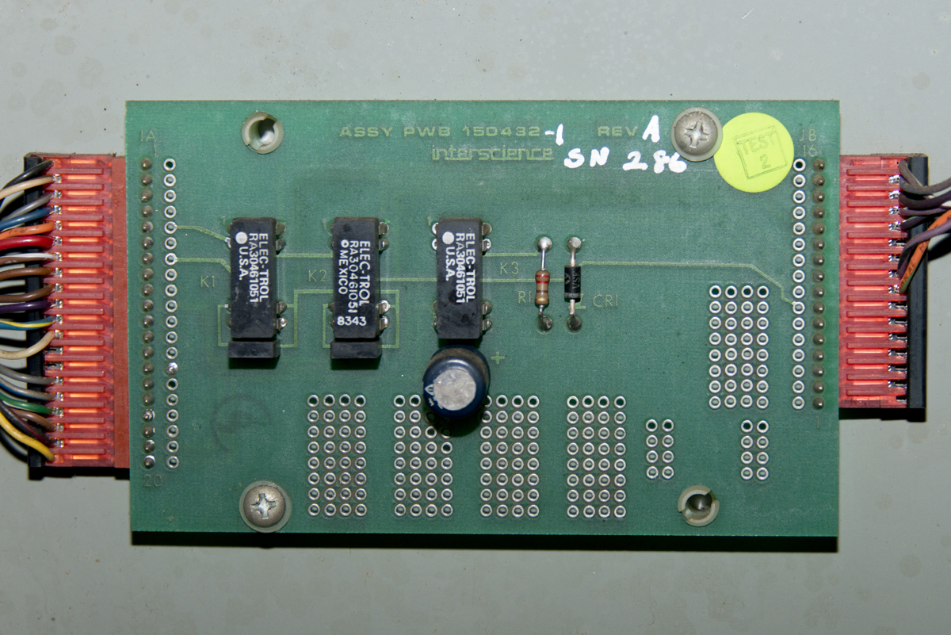
The Sound Interface Board has three DIP reed relays, two of which are used for the two main sounds, and a third which we will make functional for the reel spin sound.
Note that K1 triggers the “Win” sound, and K3 triggers the “Coin In” sound. K2 is the Reel Spin sound that is normally not used. Our project will make it function. Note the DIP relays are standard “Form-A” 5-volt reed relays should you need to replace them.
The reel sensors each have two photo-transistors arranged to read the spinning reels in binary fashion. On the backplane board, we will exploit one of these photo-transistor outputs (we chose A instead of B) through a diode, and then route the signal to a terminal from the Options Board connector that is wired to the K2 Relay on the Sound Relay board. This gets the relay pulsing during reel activity.

To start, remove the slot controller electronics enclosure to access the backplane board, and install a 1N4148 diode with a short piece of jumper wire as seen in the detailed image below. Solder the cathode of the diode (stripe end) to the connector solder pad on pin 81 of the CPU. Then solder the end of the extended wire to pin 5 of the J9 solder pad. The finished modification will look like this:
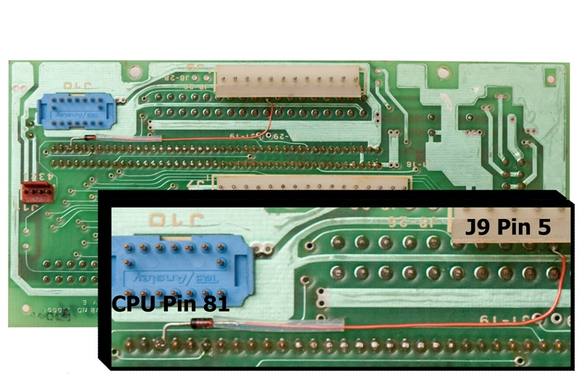

This diode intercepts the reel reader signal and directs the negative pulses to a purple wire that is connected to K2 of the Sound Relay board. By energizing that relay, the Reel Spin sound is accessed and played. However, it must be a steady signal to play the music smoothly and consistently. Those pulses make the relay chatter on and off rapidly – not good for steady sound.

The sound needs to play the entire time the reels are spinning. Since the reel spin time varies, and lasts between 2 and 6 seconds, we need to make sure the reel sound always plays, until the last reel stops spinning. To accomplish this, we will build a circuit that outputs a steady signal while the reel sensor is pulsing on and off. The one-shot design puts out a “stretched” pulse for every reel sensor pulse, and re-triggers continuously while the reel position sensor in reel 3 is active. Since the output pulses overlap, the sound stays on continuously during reel spin. The stretched pulse needs to be very short (around 40-80 milliseconds), and just enough so that it will always overlap the time between normal reel read pulses during a normal spin. A trimpot allows you to fine-tune the duration of overlap (one-shot).

We use a CMOS IC, part number MC14538B or CD4538. This IC is a dual monostable multivibrator, of which we will use only one half of it. Unused inputs from the other circuit are tied to either ground or 5 volts. We will use 5 volts from the sound board power supply to power this circuit and will modify the sound board to intercept the signal between the reel opto-isolator and the CPU input, and lengthen the signal to play the Reel Spin sound for the duration of the spin cycle.

On the Sound Board, there are five opto-couplers. Three are functional (there is no code written for the other two opto-couplers so they have no function in the circuit). From the top, the first opto-coupler controls the Coins Paid sound and the second, Coin-In sound. The third is the one that directs the CPU to play the Reel Spin sound.

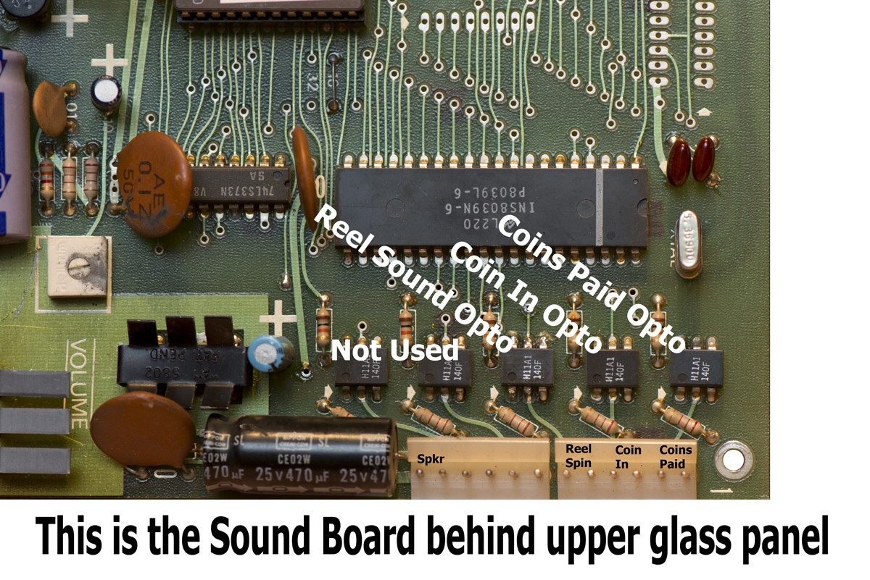

You must break the connection between the opto-coupler transistor output (pin 5) and the CPU input (pin 29). To do this, cut the trace on the bottom of the PC board as shown in the image below. Slice through the trace with a hobby knife:

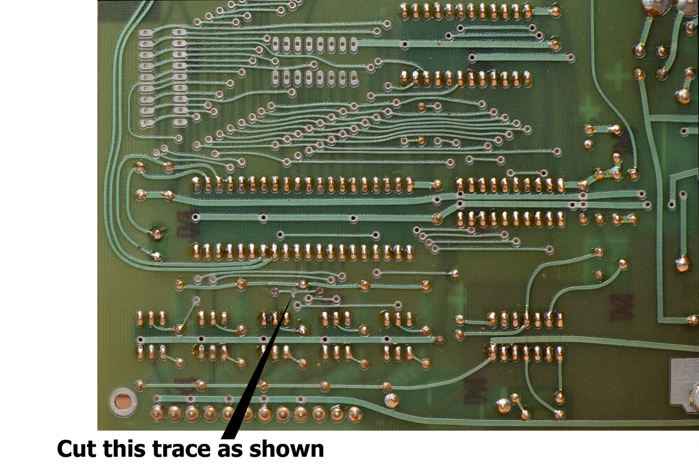

Following the schematic below, you can build the one-shot circuit to attach to the Sound Board. I used an old PC board to position the necessary components, but a standard perf-board will work just as well. Below is the schematic of the one-shot circuit, which is very simple and uses only four components (in addition to the 1N4148 diode on the backplane board):
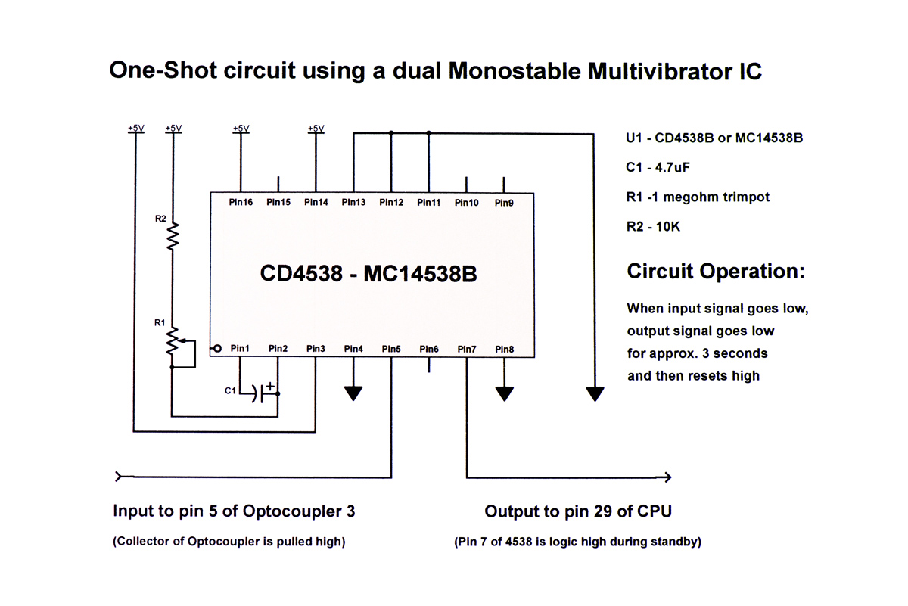
When each input signal from 3rd reel sensor A (fed to pin 5 through the opto-coupler) toggles low, output to CPU pulses low for about 1/10th second then resets high. When reel 3 is spinning, pulses are very rapid and less than 1/10th second apart. This rapid, repeating pulse train will keep the output (pin 7) low until the pulse train stops (reel 3 stops) then time out after about 1/10th second. A low output on pin 7 instructs CPU to play “Reel Spin” music. Set trimpot so that the music playing is consistent and not choppy, yet turns off about 1/10th second after last reel stops.
C1 -1.0uF 16V Tantalum capacitor
The design uses a 1-megohm trimpot to fine-tune the length of time that the reel sound plays; we want to be able to adjust it so the reel sound ends shortly after the right reel (reel 3) stops spinning, yet keeps the music consistent and smooth during reel spin. Attachments to the Sound Board will be as shown below:

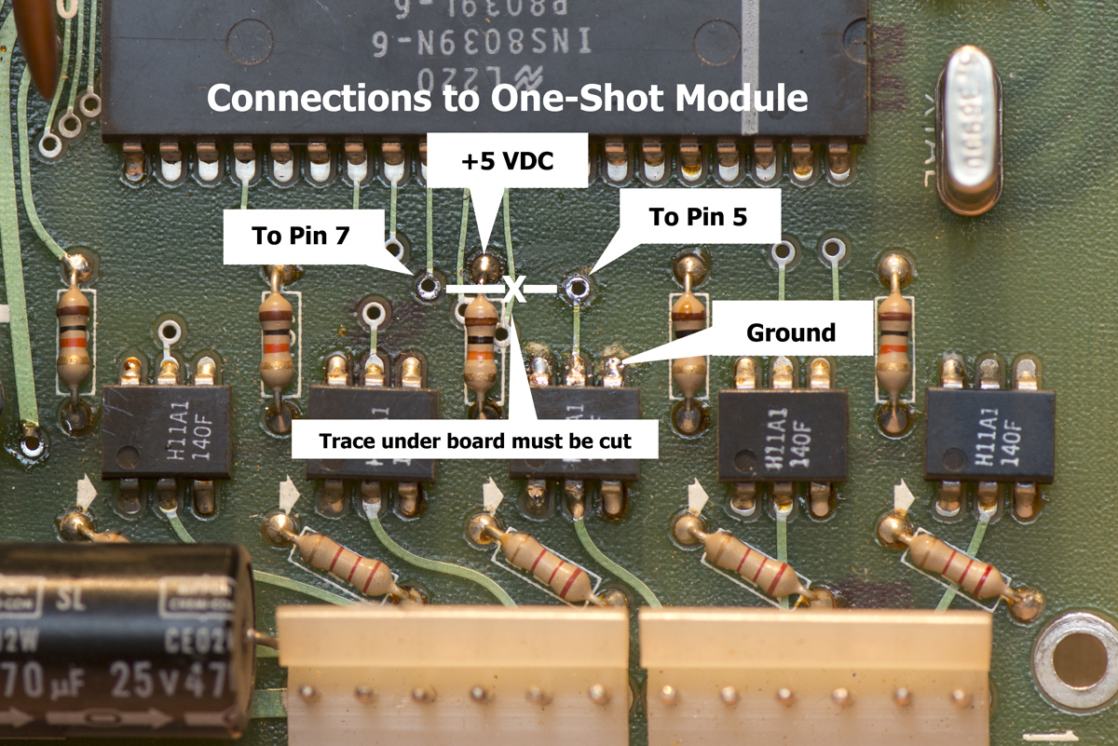

The finished project will look like this. I mounted the project board in an empty space on the sound board as seen in the image below. I used four different colors of 24-gauge wire to make it easier to install, green to Pin 5 of the 4538, blue to Pin 7. Always check your work with an ohmmeter BEFORE you power up the new circuit.

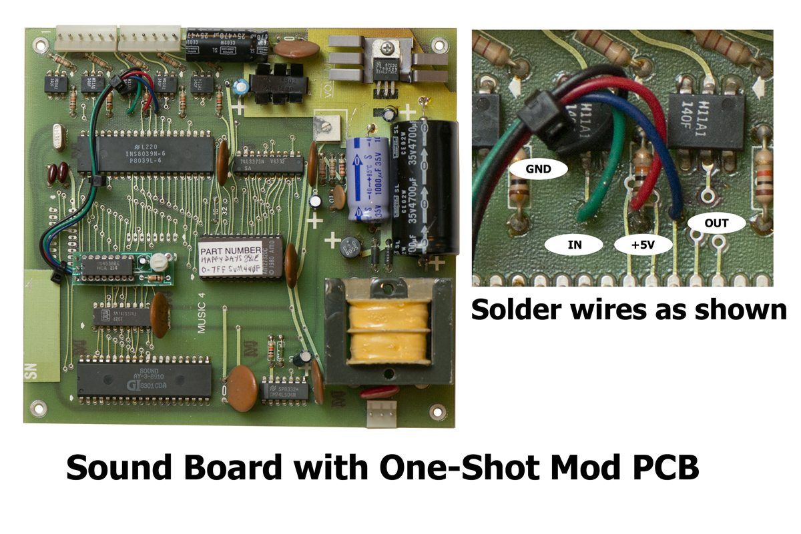
Re-install the Sound Board back into the cabinet, and be sure to re-attach both connectors. Note that the smaller 3-pin connector (seen at the bottom right corner of the image above, receives 120VAC on pins 1 and 3, as pin 2 is not connected. Set the trimpot so that the music plays smoothly during reel spin, and the music stops shortly after reel 3 stops spinning. Turning it fully one direction, the music will sound choppy during spin, and the other direction will make the music sound well after the game is over. You will find a sweet spot that both gives you smooth sound all the time, yet turns the music off very soon after the reels all stop.

So, to recap: Reel Spin signal from reel 3 pulses during play and is used to energize a reed relay. Relay contacts pulse rapidly and are attached to an opto-isolator IC on the Sound Board, which switches on and off to match the pulses. Added circuit takes those rapid pulses, and converts them to one smooth pulse. This uninterrupted pulse makes the Reel Spin sound play smoothly during reel spin.

The One-Shot timer initiates music play the instant the reels begin to spin and ends right after all reels stop spinning. You will notice that when you first power up your slot, the reel spin music may play for a split second. This is normal because the reel sensor may be in a “read” state and the circuit is responding. I considered using the unused half of the chip to provide a “power-on-input-disable function which would prevent the split second of music when you turn the machine on, but don’t feel it’s that big of a concern. So I kept it simple.

REV B Copyright ©2013 John Spina

