Summit Systems Sound Board Modification

The Summit slots fitted with themusicfeatureplay two sounds; one when the coin is inserted, and the other that plays as winning coins pass through the hopper exit.

There is, however, a third sound that doesn’t play. This sound is associated with spinning reels, but the machine doesn’t play this sound. I believe the Options Board, which is normally not found in the home-use machines, controlled this unused programmed sound.

There is a way to make your Summit machine produce a sound during reel spin. It involves fabrication of a single-chip circuit, a few components, and a means to put it all together. This mod essentially looks at the signal from the reel-spin switch – which closes momentarily when the handle is pulled – and “stretches” this signal for the approximate duration that the reels are in motion, then feeds the Sound Relay board to actuate the sound.

You can test this sound easily. The Sound Board is behind the upper glass. Open the front door, slide the glass out, and remove the fluorescent lamp panel. You will see the sound board mounted to the back wall.

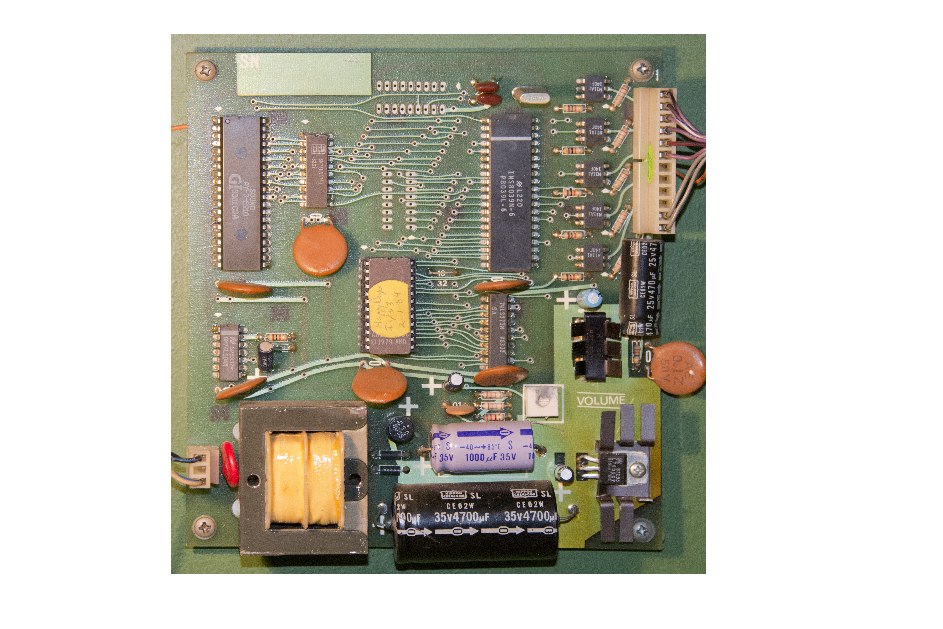
The Sound Board has two connectors; lower left is the AC power, upper right is the connection to the Relay Board and the speaker, behind and to the right of the reels. To test the sounds: Power up the machine. You will “backprobe” the terminals on the large connector. Using a pair of needle nose pliers, jump the two top pins; you will hear the “Win” sound. Now jump the next two pins down; that’s the “Coin In” sound. Finally, jumping the last two pins will play the “Reel Spin” sound. That’s the sound we’re going to make functional.
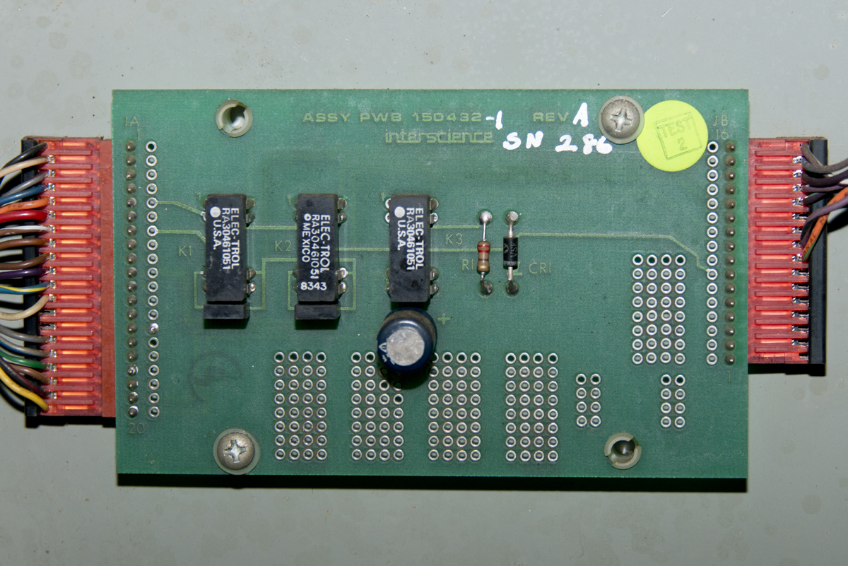
The Sound Relay Board has three DIP reed relays, two of which are used for the two main sounds, and a third which we will make functional for the reel spin sound.
Note that K1 triggers the “Win” sound, and K3 triggers the “Coin In” sound. K2 is the “Reel Spin” sound that is normally disabled. Our project will make it function.
There is a Reel Spin Switch attached to the reel assembly, lower right rear corner. When you pull the handle, the switch momentarily closes, sending a ground signal to the Slot Controller Board. On the backplane board, we will exploit this switch signal, and using a diode, feed the signal to a terminal from the Options Board connector that is wired to the K2 Relay on the Sound Relay board.

To start, remove the slot controller electronics box to access the backplane board, and install a 1N4005 diode with a short piece of jumper wire as shown below.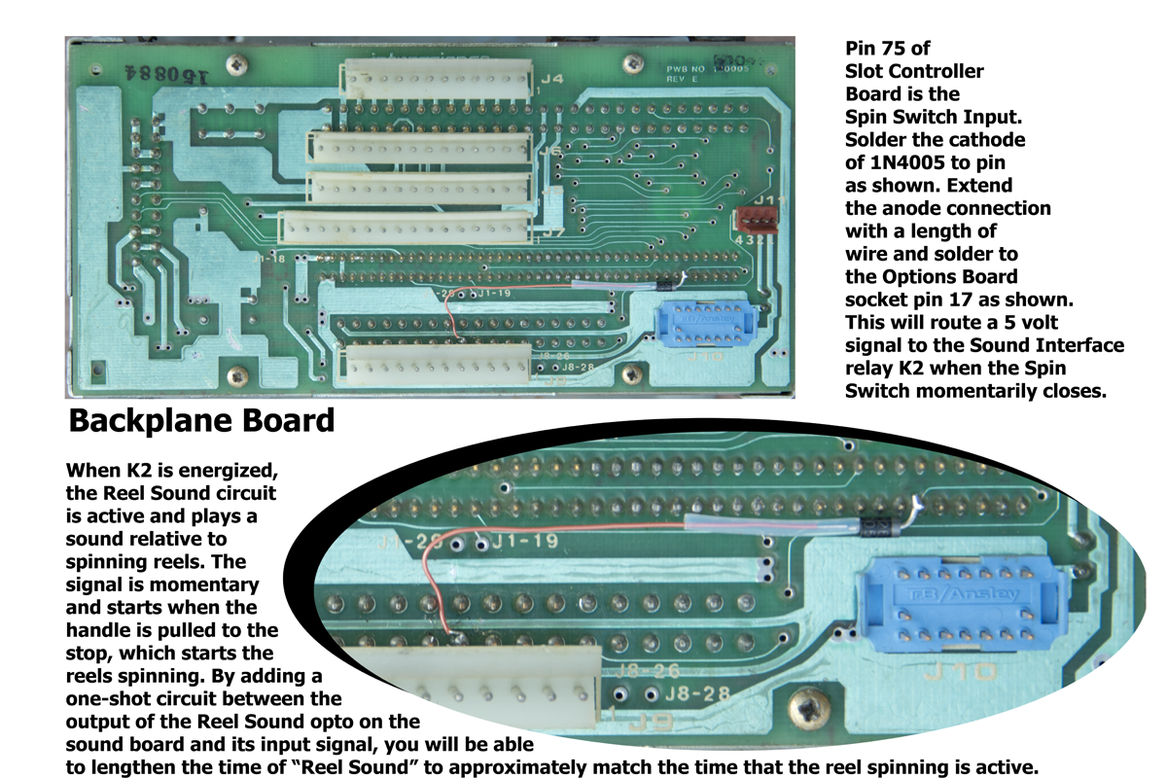

This diode intercepts the spin switch signal and directs it to a purple wire that is connected to K2 of the Sound Relay board. By energizing that relay, the 3rd. sound is played. However, it only plays for a fraction of a second,which is the amount of time the spin switch is closed (basically closes and opens quickly to tell the Slot Controller that the reels are starting to spin).

The sound needs to last longer – for the entire time the reels are spinning. Since we know all three reels spin for 2-3 seconds, we will build a timed circuit that will time out to the same approximate time the reels are actually spinning. To accomplish this, we will build a circuit that functions as a one-shot timer to keep that sound playing (approximately 2-3 seconds).

We will use a CMOS IC, part number MC14538B or CD4538. This IC is a dual monostablemultivibrator, of which we will use only one half of it. Unused inputs from the other circuit should be tied to either ground or 5 volts. We will extract the 5 volts from the sound board power supply to power this circuit and will modify the sound board to intercept the switch signal and lengthen the signal to play the reels sound for the duration of the spin cycle – the output of our circuit being the CPU signal input and the and the input of our circuit being the opto coupler transistor signal – which we tied to the Spin Switch thru the use of the diode on the backplane.

On the Sound Board, there are five opto-couplers. Three are functional (there is no code written for the other two opto-couplers so they have no function in the circuit). From the top, the first opto-coupler controls the Win sound and the second, Coin-In sound. The third is the one that directs the processor to make the Reel Spin sound.

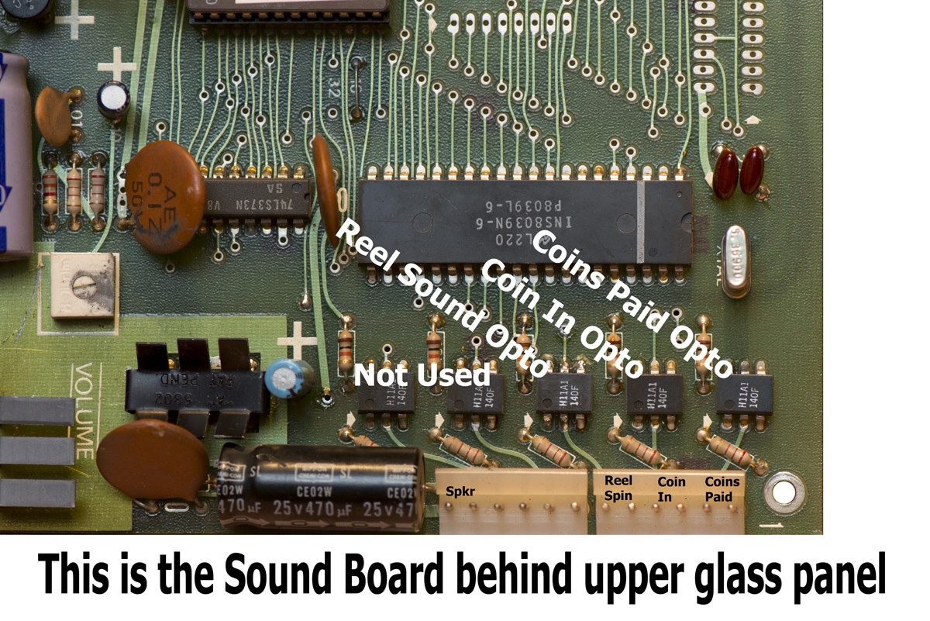
Youmustbreak the connection between the opto-coupler transistor output (pin 5) and the CPU input (pin 29). To do this, cut the trace on the bottom of the PC board as shown in the image below. Slice through the trace with anXacto knife:

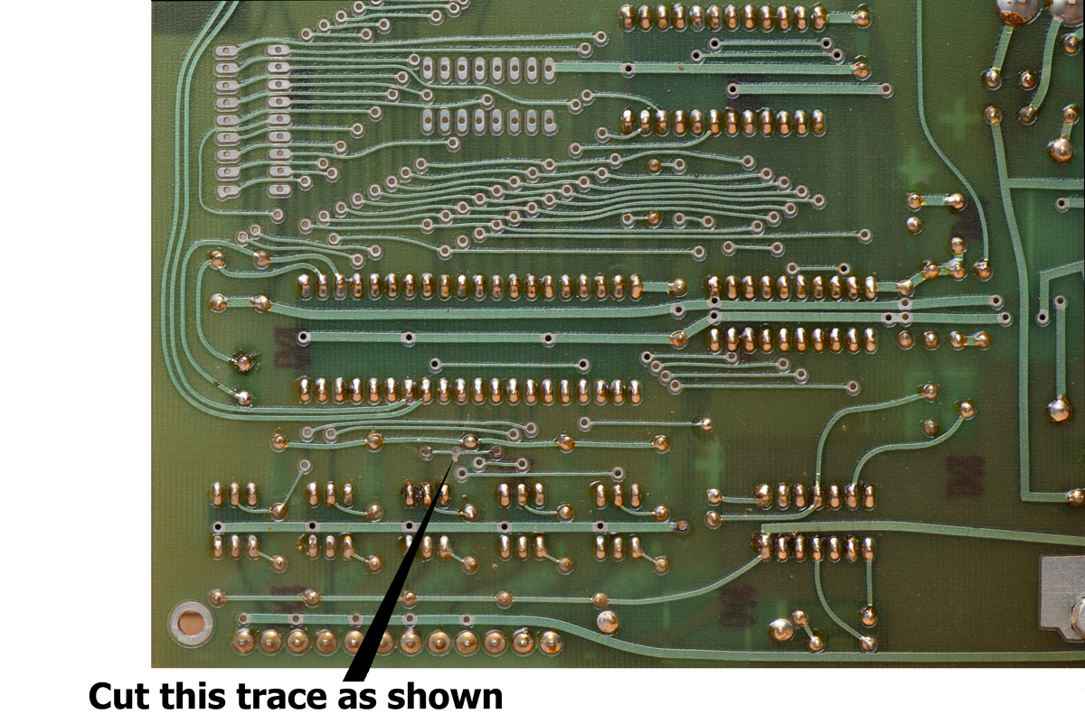
Following the schematic below, you can build the one-shot circuit toattach to the Sound Board. I used an old PC board that I was able to position the necessary components on, but a standard perf board will work just as well. Below is the schematic of the one-shot circuit, which is very simple and uses only four components (in addition to the 1N4005 diode on the backplane board):
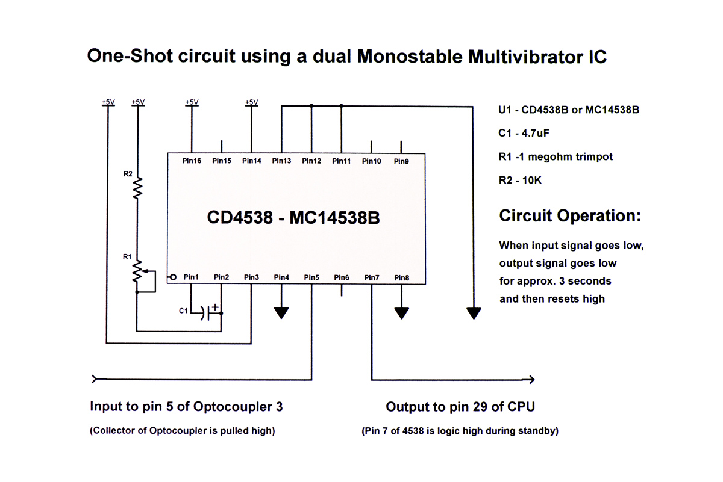
The design uses a 1-megohmtrimpot to fine-tune the length of time that the reel sound plays; we want to be able to adjust it so it ends as soon as the right reel stops spinning. Attachments to the Sound Board will be as shown below:

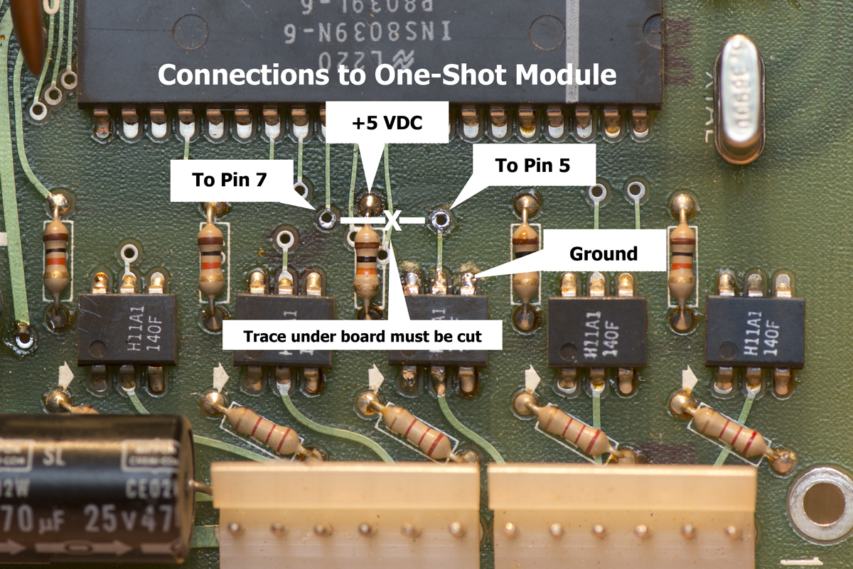
The finished project will look like this. I mounted the project board in an empty space on the sound board as seen in the image below. I used four different colors of 24-gauge wire to make it easier to install, green to Pin 5 of the 4538, blue to Pin 7. Always check your work with an ohmmeter BEFORE you power up the project.

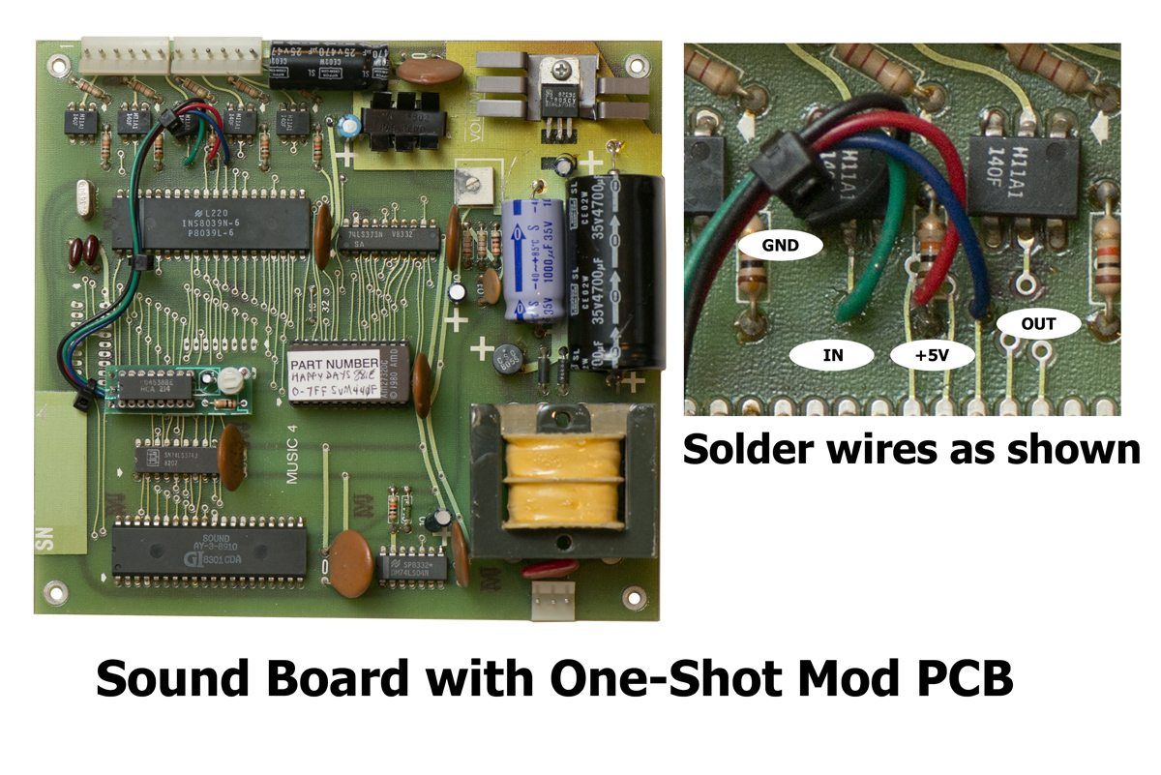
Re-install the Sound Board back into the cabinet, and be sure to re-attach both connectors. Note that the smaller 3-pin connector (seen at the bottom right corner of the image above,receives 120VAC on pins 1 and 3, aspin 2 is not connected.You can test your sounds by jumping the 3rd. pair of pins from the end on the large connector to simulate spinning reels, or simply install in the machine, insert coin, and pull the handle. Set the trimpot so that the sounds run for about 2-3 seconds. You will need to tweak the setting once you check it against the reel spin time so that it roughly matches the amount of time the reels are spinning: Soundstarts when the reels begin to spin and stops when the last reel quits spinning.

The One-Shot timer initiates the instant the handle switch input is sensed, and begins the timeout when the switch is released, so if you should hold the handle down and not release it, the reels sound will stay on continuously. Releasing the pull handle starts the timout sequence. Because the total reel run time will vary due to the randomness of the stops, the sound length could possibly be a bit shorter or a bit longer than the reel rotation. You’ll find a happy medium within the trimpot range.

As a footnote, there is actually a more precise way to extract a “spinning reels” signal using the output from one of the two right reel binary optical sensors. Using that sensor to trigger the One-Shot circuit would keep the Reel Sound length consistent with the last spinning reel (you would also have to change the capacitor to a 0.22uF), but I didn’t want to risk disturbing that signal to the CPU, so I went with the next best thing. -JS
Copyright ©2013 John Spina

